**Chapter 4: DYNAMIC PROGRAMMING**

**Topic – 1: Summary**

* Introduction
* The principle of optimality
* Making change problem
* The 0-1 knapsack problem
* Shortest path Floyd’s algorithm
* Matrix chain multiplication
* Longest common subsequence

**Topic – 2: Introduction**

**Definition**

* **Dynamic programming (DP):** Stage-wise search method for problems using a **series of decisions**.
* We keep a **table** of known solutions to **avoid** solving same problem twice.
* So, **DP** is same as **greedy algorithm** but **avoids** calculating same thing more than once.

**Bottom-Up Approach**

* In bottom-up approach, first we solve the **smallest** sub-problem.
* Then after **solving & combining** that sub-problem, we again check the smallest problem from available sub-problems.
* We continue this loop until all the sub-problems have been solved.

**Divide & Conquer v/s Dynamic Programming**

|  |  |
| --- | --- |
| **Divide & Conquer** | **Dynamic Programming** |
| **Recursively solves & combines sub-problems.** | **Recursively solves & combines sub-problems but avoids solving same problem twice.** |
| **Works best when sub-problems are mutually independent.** | **Works best when sub-problems might be mutually dependent.** |
| **Less complex.** | **More complex.** |
| **Top-down approach.** | **Bottom-up approach.** |
| **For example, merge sort & binary search etc.** | **For example, Fibonacci series & 0-1 knapsack problem.** |

**Dynamic Programming v/s Greedy Algorithm**

|  |  |
| --- | --- |
| **Dynamic Programming** | **Greedy Algorithm** |
| **Each step is determined by which sub-problem is smallest.** | **We make the most optimal (greedy) choice at each step.** |
| **Bottom-up approach.** | **Top-down approach.** |
| **Can be slower.** | **Usually fast.** |
| **More complex.** | **Mostly simple.** |

**Topic – 3: The Principle Of Optimality**

**Introduction**

* It’s a law which when **not** applied to a problem, we **can’t** solve it using **DP**.
* For example, when we have **limited resources**, then DP might **not** help us.
* However, **principle of optimality** can be applied on **most** problems.
* These will be **most optimal solutions** obtained from combining **many optimal solutions**.
* But the issue is that this principle is **unreliable**.

**Make A Change Problem**

* Suppose the example from previous chapter about the **currencies**.
* We have coins for **1-unit**, **4-units** & **6-units**.
* Now we need to provide **change** of **8 units** to a customer.
* Greedy algorithm will result in payment of **one** **6-unit** coin & **two** **1-unit** coins.
* While, DP will do so with **two 4-unit** coins, which is clearly **more optimal**.

**Goal: To find minimum number of coins required.**

**Algorithm:**

**Step 1: Make various combinations of coins like (1), (4), (6), (1,4), (4,6), (1,6), (1,4,6).**

**Step 2: When taking each combination, keep coins with higher values ahead.**

**Step 3: See how many large coins cover the target value or little less than it.**

**Step 4: Then try fixing the immediate smaller value in gap**

**Step 5: Then lower it by one unit & try again fixing the immediate smaller value in gap.**

**Step 6: Repeat step 4 & 5 recursively.**

**Step 7: Keep the number of coins involved in a list.**

**Step 8: Search for the shortest value & return it.**

**Simulation:**

**1 🡪 {1,1,1,1,1,1,1,1}**

**1,4 🡪 {4,4}, {4,1,1,1,1}, {1,1,1,1,1,1,1,1}**

**4,6 🡪 {6}, {4,4}**

**1,6 🡪 {6,1,1}, {1,1,1,1,1,1,1,1}**

**1,4,6 🡪 {6}, {6,1,1}, {4,4}, {4,1,1,1,1}, {1,1,1,1,1,1,1,1}**

**We see that {6} alone doesn’t fulfil the need for 8.**

**And we also see that {4,4} fulfils our need with least number of coins.**

**We also have choice to represent the same in from of table for better visualization.**

**Topic – 4: Knapsack Problem**

**Introduction**

* In knapsack problem, we have some items with **weight** & **value**.
* We have to find the **combination of items** such that they stay within the **weight limit** but provide the **highest value**.

**Types Of Knapsack Problem**

* **0-1 knapsack problem:** When choosing an item, it has to be picked up as a **whole** & **not** some part of it. It can be solved using **dynamic programming**.
* **Fractional knapsack problem:** We can also choose a **fraction** of an item. It can be solved using **greedy algorithm**.

**Contrary Greedy Behaviour**

* **Greedy algorithm** will start picking the **largest value** first & other values might **not** be able fill the weight gap.
* So, the **total value** might **not** be the **max value** possible.

**Note!**

**🡪 Weight is just a limit, no need to reach the limit if we get the highest value beforehand.**

**Knapsack Table**

* We can solve **knapsack problem** & find the combination with **max value** within a weight limit, using ***knapsack table***.
* In it, **rows** represent **max weight** & **column** represent the **index of our elements** (starting from **1**, not **0**).

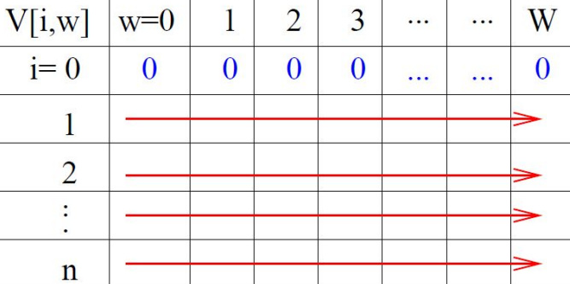

* We can compute it **row-by-row** or even **column-by-column**.

**Steps Involved**

* **Step 1:** We check **one-by-one** each element by their **weight**.
* **Step 2:** Then **add value** of next element if they **don’t** cross the weight limit.
* **Step 3:** If we see possibility of getting **more value** from **discarding** an element & **adding** another, then we do so. But in a set of large number of elements, how do we do so?

**We use this formula:**

**V[i, w] = max(V[i – 1, w], vi + V[i – 1, w – wi])**

**Notice that this formula is actually recursive.**

**Example**

**Ques: Weight limit (W) = 10 for:**

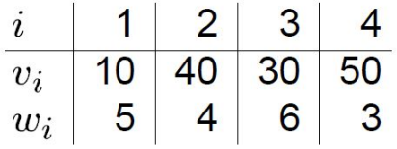

**Ans:**

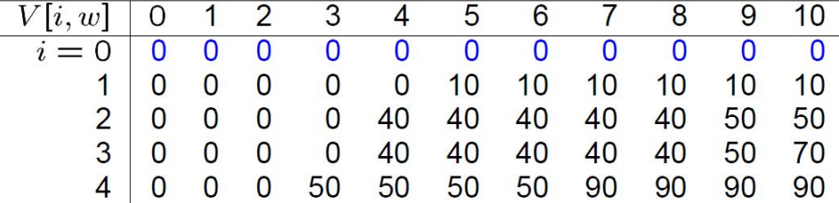

**Computational Complexity**

* **Time complexity –** O(nW)
* **Space complexity –** O(W)

**Topic – 5: Chain Matrix Multiplication**

**Concept**

* A chain of matrix (**A1, A2, A3, …, An**) which have to be **multiplied**.

**Possibilities**

* Suppose there are **4** matrices **A1, A2, A3, A4**.
* There are **5 ways** to compute the product.

**(A1(A2(A3A4)))**

**(A1((A2A3)A4))**

**((A1A2)(A3A4))**

**((A1(A2A3))A4)**

**(((A1A2)A3)A4)**

**Necessary Parameters**

* To multiply **two matrices**, we need some necessary **parameters**.
* These parameters are the **algorithm** & **matrix dimensions**.

**Algorithm**

**Rule 1: Number of columns in first matrix must be equal to number of rows in another.**

**Rule 2: Third matrix’s each element must be initialized to 0.**

**Rule 3: There are three loops involved – Outermost having [1, r1], middle one having [1, c2] & innermost having [1, c1].**

**Rule 4: Line for calculation is: m3 += m1[r1][c1] * m2[r1][c2]**

**Rule 5: Return the two-dimensional array now.**

**Brute Force Method**

* **Scalar multiplications:** All the multiplications involved between two matrices.
* ***Parenthesizing*** the chain of matrices properly can help us **reduce** the total number of **scalar multiplications**.

**Dynamic Programming Approach**

* **Step 1:** We make an **optimal parenthesizing** by finding two such matrices from the given matrices, which give smallest number of **scalar multiplications**.
* **Step 2:** It will be where (**r1 * c2 * c1**) is smallest.
* **Step 3:** We will repeat **step 1 & 2** until **all** matrices has been calculated.

**Note!**

**🡪 Note how we are solving the matrix problem by taking one sub-problem at a time.**

**🡪 So, that’s how it comes under category of dynamic programming.**

**Computation Cost**

**Let cost of computing be called CC.**

**Total cost = CC(A1) + CC(A2) + CC(Scalar multiplications)**

**m[i, j] = m[i, k] + m[k+1, j] + pi-1pkpj**

**Here, i-1 < j < k.**

**Example**

**Ques: Given a chain of 4 matrices A1, A2, A3, A4 with p0 = 5, p1 = 4, p2 = 6, p3 = 2, p4 = 7. Find m[i, j].**

**Ans:**

**Dimensions:**

**A1 🡪 p0 * p1**

**A2 🡪 p1 * p2**

**A3 🡪 p2 * p3**

**A4 🡪 p3 * p4**

**Topic – 6: Subsequence**

**Introduction**

* **Deriving** a **string** from **another string** after **deleting** certain elements.

**Common subsequence:**

**ABCDH, AEDFHR 🡪 ADH**

**Longest Common Subsequence Problem (LCS)**

* Suppose **'i'** to be the pointer pointing to string **X**.
* And **'j'** is doing so with **Y**.

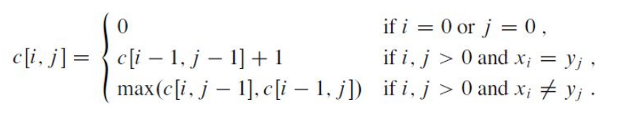

**Example**

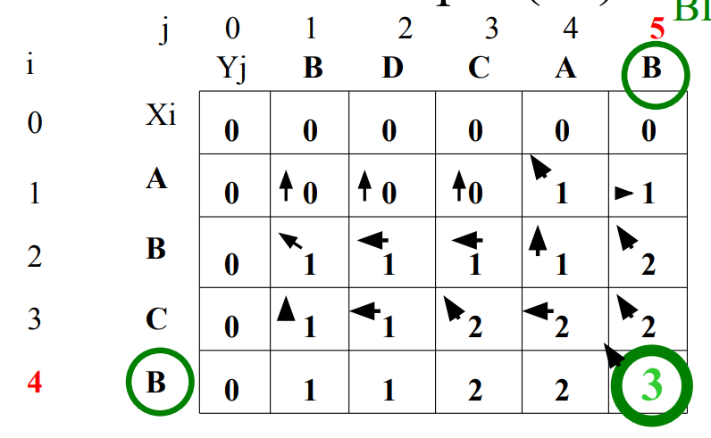

* Drawing a **line**, following **arrow directions** from the **last element** leads us to **non-zero** & cornered arrow boxes of **B**, **C** & **B**.
* So, **BCB** is our answer.
* **X values** (vertical) are called **president**.
* **Y values** (horizontal) are called **providence**.

**Algorithm:**

**Step 1: For i = 0 or j = 0, the box will be 0.**

**Step 2: By default, a cell’s value is 0.**

**Step 3: We check which one of {matching symbol}, {immediate upper cell} & {preceding character} is largest. Preference for writing arrow is in same order.**

**Step 4: We write the largest one of the three in the box.**

**Step 5: But whenever a character matches, we increment the cell’s value.**

**LCS Algorithm Runtime**

* **Time complexity –** O(m*n)
* **'m'** is number of elements in first array while **'n'** is in another.

**Topic – 7: Principle Of Optimality**

**Floyd’s Algorithm**

* For a given graph, we can find the **shortest path** from one node to another easily through matrix.
* This matrix contains **shortest distance** from one node to another.
* **Unknown distance** from any one node to another is put as **infinity** initially.